**Reports**

**Introduction -** This report analyzes the usage patterns and academic performance of students who visited the University Study Center (UWC) during the full academic year 2000 - 2001. The data reveals several key trends and insights. The data reveals several key trends and insights, providing valuable information for optimizing USC services, future strategies to improve student support and maximizing their impact on student success.

**Key Findings**

1. **Gender-Specific Observations**:

~~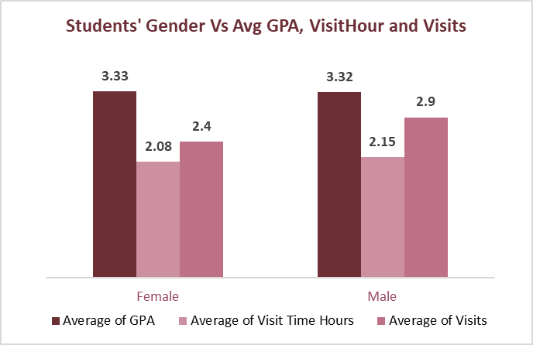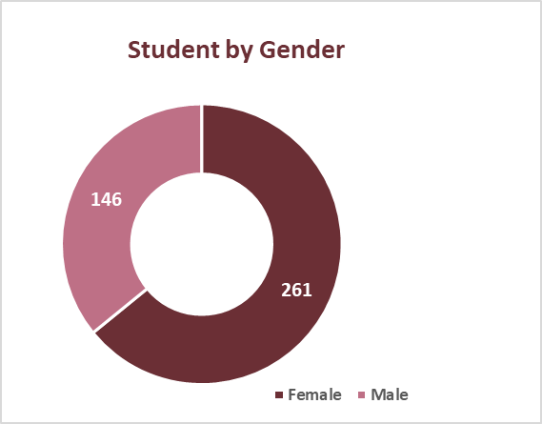~~

* **Female Dominance**: Approximately 2 out of 3 students that visited University Study Center (USC) are female (261 of 407 total students).
* **Higher VisitTime Hours**: Female students spend more time at the USC (2.08 hours) compared to male students (2.15 hours). This could indicate different academic needs or preferences for the male students.
* **Frequency of Visits (Visits):** Female students are approximately 2 times (64%) more likely to visit the USC more than male students.
* **Student Engagement**: Female students have slightly lower average visits (2.4) compared to male students’ average GPA of 2.9, but their average GPAs are very close (3.33 for females, 3.32 for males). This might indicate different academic needs or preferences for the female students. Also, it suggests that gender doesn’t significantly impact academic performance in this context.

1. **Performance Insight**:

* **Center Performance:** The CSC shows the highest average GPA (3.41) among all centers, followed closely by the University Writing Center (3.40).
* **Major-specific Performance:** Music majors have the highest average GPA (3.93), while Cybersecurity majors have the lowest (2.90).
* **Ethnic Performance**: Asian students have the highest average GPA (3.52) with relatively high average visits (2.94). Black or African American students have the lowest average GPA (3.12) but higher average visits (2.95) compared to White students (2.21 visits, 3.37 GPA).

1. **Center-Specific Insights or Center Utilization**:

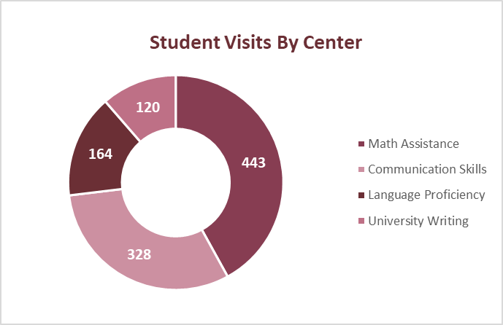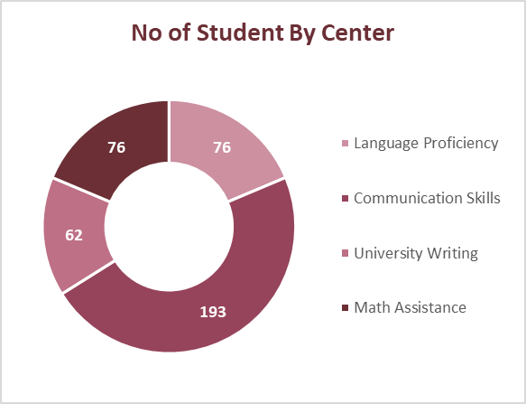

* **Math Assistance Center (MAC) Dominance**: The MAC is the most popular center, with 443 visits, followed by Communication Skills Center (CSC) with 328 visits. This suggests a high demand for math and communication skills support.
* **Communication Skills Center (CSC) Popularity**: The CSC has the highest number of unique students (193), indicating its services are widely recognized and utilized, although students visited less frequently and spent less time there than at the MAC. Meanwhile, MAC and Language Proficiency Center (LPC) both have 76 unique students each.
* **Trojan Tutoring (TT) and University Writing Center (UWC) Underutilization**: Both TT and UWC have significantly lower visit counts compared to the MAC and CSC, suggesting potential underutilization of these services.

1. 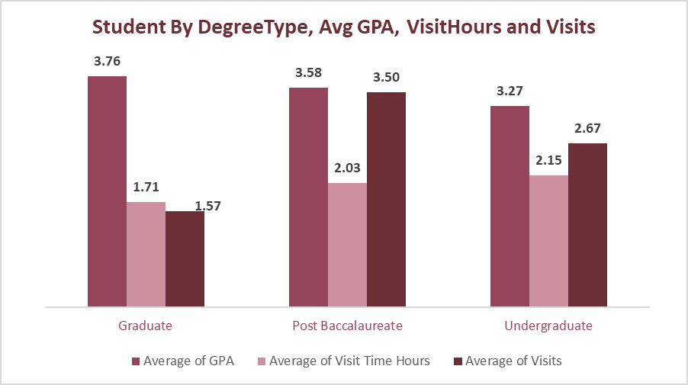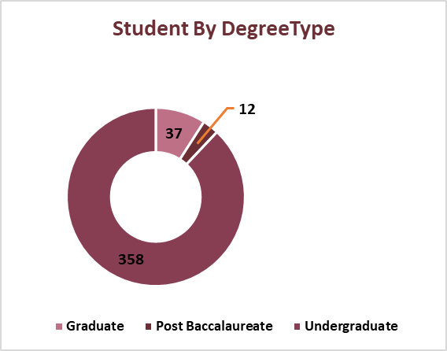**Student Demographics**:

* **Undergraduate Dominance**: Undergraduate students are the primary users of the USC, with 358 visits compared to 37 visits by graduate students, and they are likely to visit USC approximately 10 times than graduate students. This suggests that undergraduate students may require more academic support or that the USC services are more accessible to them.
* **Graduate Student Success**: Despite fewer visits (1.57 vs 2.67), Graduate students have a slightly higher average GPA (3.76) compared to undergraduate students (3.27). This could be attributed to factors like higher motivation, more focused academic or career paths, or a greater understanding of their learning needs.

1. **Visit Frequency and GPA**:

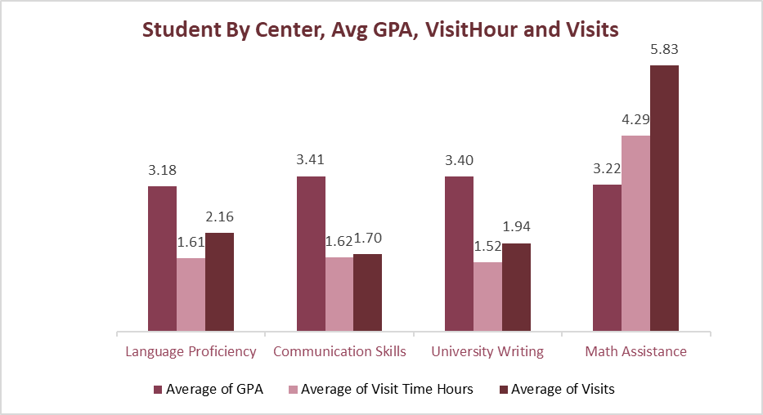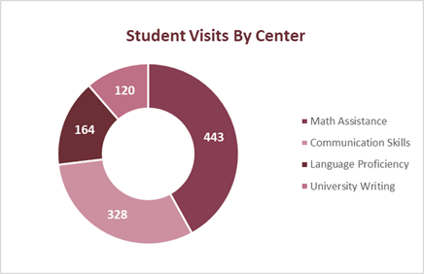

* **No Direct Correlation**: The frequency of visits to USC does not directly correlate with higher average GPAs. For example, the CSC has a slightly higher average GPA (3.41) than the MAC (3.22), despite having fewer visits.
* **Diverse Factors**: This suggests that while USC usage is important, other factors like individual learning styles, study habits, and course difficulty also contribute to academic performance.

1. **Major-Specific Observations**:

* **Highest Number of Students By Major**: The top 5 majors with the highest number of students are Biology Nursing, General Studies, Management and Accounting. (See Dashboard)
* **High GPA Majors**: Top majors like Music, Information Science, Applied Science, Political Science, and Bioinformatics have a higher average GPA of 3.76 and above than the overall average of 3.33.
* **High Visit Majors**: Top majors like Electrical & Computer Engr, Psychology, and Business Administration spent more than with a higher VisitTime Hours of 4.42 and above than the overall average visit time of 2.10.
* **High VisitTime Hours Majors**: Top majors like Electrical & Computer Engr, English and Psychology visits more frequently with a higher Visits of 4.93 and above than the overall average visit time of 2.59.

**Key Recommendations**

Given our findings, the following recommendations are crucial to optimize USC services and maximize their impact on student success:

1. **Analyze High-Performing Center and Leverage CSC Success**: Conduct thorough analysis of the CSC to identify their successful study practices strategies that can be potentially applied to other centers to increase engagement across the centers.
2. **Analyze Return Visits, Awareness Creation and Optimize High-Traffic Centers:** Promote MAC resources through social media, email newsletters, campus events, student orientations, and collaborations with student organizations to optimize MAC resources given the low number of student visits to MAC compared. However, analyze the reason behind student return visits (Visits frequency) in MAC to provide insights into student needs and help tailor USC services to increase satisfaction and retention. Likewise, given the significant frequency of MAC total visits, MAC resources and hours of operation should be expanded to accommodate student demand.
3. **Awareness/Promotion for Underutilized Centers**: Increase awareness for TT and UWC through faculty events, student orientations, or collaboration with student organizations to encourage more students to use the TT and UWC services.
4. **Enhance Support for Undergraduate Students**: Consider developing tailored programs or workshops for undergraduate students, who have a lower average GPAs compared to graduate students to address their unique academic needs and improve their average GPA.
5. **Longitudinal Study**: Conduct a longitudinal study to track students’ GPA changes over time in relation to their use of USC services to measure long-term impact of the USC services.
6. **Targeted Outreach for Lower-Performing Majors**: Develop targeted outreach or programs for majors with lower average GPAs to promote USC services and encourage their participation.
7. **Investigate Gender Disparity and Specific Center with High Visits:** Address gender imbalance by investigating why female students and the MAC have significantly higher visit times. Ensure comfort and accessibility for all genders at USCs. Continue to encourage female students to visit and leverage on their referrals to encourage more consistent usage among female students. Develop initiatives to increase male student participation through events, programs, and outreach etc.
8. **Feedback System**: Regularly conduct feedback including pre- and post-semester surveys and questionnaires, to understand student needs and preference for continuous improvement of services.
9. **Encourage Faculty Collaboration**: Work with faculty heads, especially for courses with lower average GPAs, to integrate USC services into their curriculum or advising processes.
10. **Diversity and Inclusive Initiatives**: Address potential disparities in academic performance among different ethnic groups by offering targeted support and resources. Create more awareness to ethnic groups with lower visit rates to boost their participation.
11. **Monitor Trends**: Regularly monitor and analyze trends or patterns to help adjust USCs strategies and operations in a timely manner.

**Conclusion**

The University Study Center plays a crucial role in supporting student academic performance. While usage patterns vary across gender, major, and academic level, there are clear opportunities to enhance USC’s impact. By implementing the recommended strategies, the USC can further optimize or better tailor its resources to meet diverse student needs, enhance student engagement, promote equitable access to academic support, and maximize its positive impact on student success. Regular monitoring and adaptation will be key to ensuring the USC continues to effectively serve the evolving needs of the student population.